**Final Project – NASA Images from Space**

**NASA APIs and Images**

**Paul Kiefer – JS300**

* Home Screen – NASA APOD (Astronomy Picture of the Day) image and description including the ability to change dates and reload images

NASA Images from Space

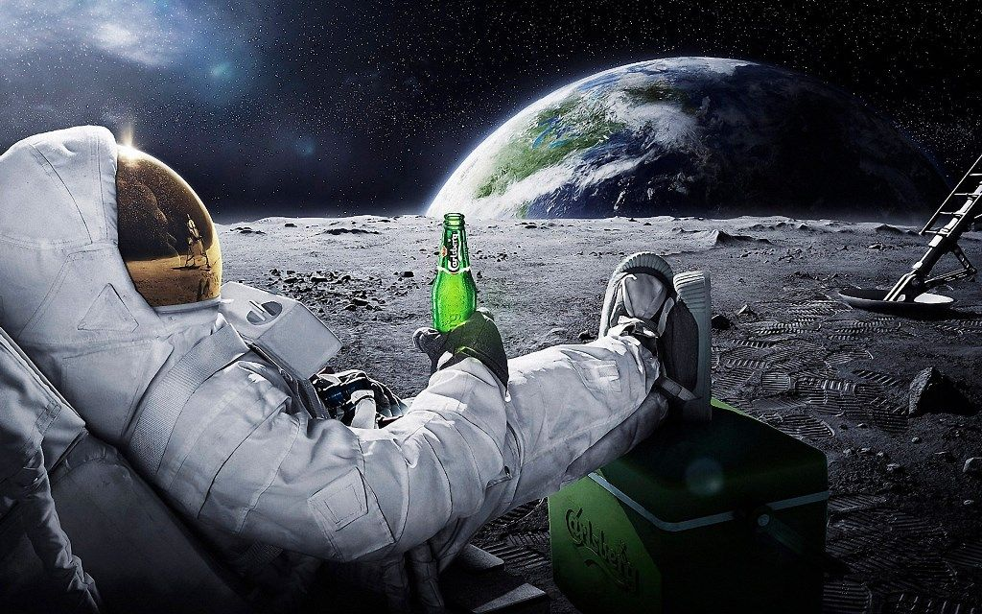

Description about NASA and the images available.

APOD

Image Search

* NASA APOD (Astronomy Picture of the Day) image and description including the ability to change dates and reload images

NASA Images from Space

Home

**Astronomy Picture of the day**.

Find

Date

Image description

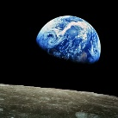

* NASA image search

NASA Images from Space



**NASA Image Search**.

Find

Search For

Short Desc

Link

Short Desc

Link

Short Desc

Link

Short Desc

Link

Short Desc

Link

Short Desc

Link

Short Desc

Link

Short Desc

Link

**Who is this for…**

This is for someone who enjoys looking at cool pictures of space or has an interest in space and the space program.

**Task List**

1. Create project with create-react-app
2. Design pages and flow of the site
3. Determine data needed from APIs
4. Design state to easily make pages interactive

**Dependencies**

1. Connect to NASA APOD API
2. Connect to NASA Image and Video Library API

**Weekly Plan**

1. Week 1
   1. Create plan
   2. Create project
   3. Confirm API connections (no CORS issues)
2. Week 2
   1. Create Home page
      1. Create title bar as component
      2. Create wrapper div for homepage which holds other components
      3. Create clickable button for APOD page
      4. Create clickable button for image search page
      5. Create onClick functions for buttons
      6. Add state elements for buttons
   2. Create APOD page
      1. Create APOD search div element with textbox, button and label (Component)
      2. Add state update function for textbox
      3. Add date validation for textbox
      4. Add onClick handler for button press
      5. Add div with image tag to display returned image
      6. Wireup fetch call to API and record results to state
3. Week 3
   1. Create Image Search page
      1. Create NASA image search div with textbox, button and label (Component)
      2. Add state update function for textbox
      3. Add onClick handler for button press
      4. Create Component to display API call short results – include title and clickable link
      5. Create image component to show clicked image link